## Amindii

The Amindii are sophonts native to Regina (Spinward Marches 1910), a habitable moon of the gas giant Assiniboia and the seat of the Duke of Regina. Comprising less than a quarter of the population of their world, the Amindii remain the dominant sophont in Regina’s rural environments. While most maintain their traditional culture in self-governing territories, many Amindii participate in Regina’s wider society, and some have left Regina to become Travellers in the wider galaxy.

### Physical Characteristics

The Amindii are upright bilateral beings with four arms and two large legs. Superficially resembling Terran grasshoppers, the Amindii have internal skeletons within their exterior of chitinous plates and finely scaled skin. Adults average 2.2 metres tall and mass approximately 110 kilograms. External coloration varies with tribes but tends towards patterns of blue and purple which evolved as camouflage in Regina’s native forests.

The Amindii’s four arms end in hands with four chitinous fingers, one larger ‘thumb’ opposing the other three. The two large legs are unguligrade, ending in chitinous hooves. Two additional legs have become vestigial since the Amindii became upright walkers and exist only as small appendages that facilitate reproduction.

The Amindii head is composed of a large round skull plate encasing the brain and a facial plate which contains two small eyes and an opening for the large vertically split beak-like mouth. Vision is focused on near ultraviolet to green spectra, with colours from yellow to red appearing brown or grey to the Amindii. Hearing is limited to fairly insensitive ear holes at the junction of facial and skull plates, but an Amindii’s entire body acts as a receptor of infrasound. Smell is accomplished by receptors within the mouth and is both acute and closely associated with taste.

### Evolutionary Development

The Amindii are members of Regina’s most common surface fauna phylum, though they have essentially shed two of their eight limbs as they became upright walkers. Amindii evolved in the forests of Regina. Their ancestors were small-group herbivores, but the Amindii became omnivorous to allow them to take advantage of a wider set of food options as hunter/gatherer bands. Regina’s high rate of volcanism, including relatively frequent supervolcano eruptions likely provided the seed to spark sentience in the proto-Amindii as they struggled to find food and survive amidst the ash fall and harsh climactic conditions in the aftermath of such events. Intelligence and tool use emerged as a substitute for the hibernation reflex employed by most Reginan fauna and gave the proto-Amindii a strong advantage in exploiting scarce resources while others slept through the worst aftermaths of volcanic eruptions.

### Life Cycle

As with much of Reginan fauna, the Amindii have three genders: an Egg Donor, an Activator, and a Bearer who carries the fertilised embryo to term over a period of approximately 300 standard days. While mating usually involves simultaneous contact between all three genders, a Bearer can act as an intermediary, carrying an egg for up to a week before its fertilisation by an Activator. Most births are singular, though monozygotic twins do occur if an embryo splits during early development. The three parents of the offspring are called a Triad, but this formation is specific to the offspring and not a permanent familial unit. The distribution of genders is far from equal with Activators only one-third as common as Bearers and only half as common as Egg Donors.

An Amindii is considered an adult at 14 standard years and has a natural life expectancy of 65-80 years. Amindii children are able to walk at birth and require less care than human offspring. Familial relationships are weak, with Activators and Egg Donors less involved with their children and likely to have deposited their genetic material with multiple Bearers over the course of their reproductive lifetimes. Amindii children are raised communally within their tribe, band, or village unit.

Bearers are the only gender to retain conscious control of the ability to enter a state of hibernation. All Amindii have retained an innate sense of life-detection from their forebearers. This sense allows them to locate both other Amindii and prey animals in a dense forested environment.

### History

Proto-Amindii achieved full sentience at least 200,000 years ago, based on archaeological evidence of tool use on the continent of Noncredo. Emergence of upright walking behaviour occurred prior to 5 million years ago, with the shift from herbivorous forest gatherer bands to omnivorous hunter/gatherer behaviour correlated to the emergence of tool use on Noncredo, though a minority of paleoxenologists have put forth competing origin theories involving other continents. It is certainly true that these hunter/gatherers had reached the continents of Feni, Makan, Ishkis and Queenland prior to 50,000 pre-Imperial, forming the basis of the five present Amindii cultures: the Tida*ii of forests of Noncredo, the Mi*tii of the forests of Ishkis, the Ni*damii of the northern moors of Feni, the Ka*tamii of the archipelagos of Makan, and the Idinii of the caverns of Queenland.

Technology developed slowly and in parallel amongst the divergent Amindii populations, with agriculture supplementing a traditional lifestyle and permanent villages forming the basis of tribal life. The Amindii remained close to their forest origins, except in Queenland, where the Indinii culture spent much of its developmental period in a semi-subterranean existence, residing in the region’s extensive limestone and volcanic cave systems rather than in forest villages.

By -1000, the Amindii had advanced to TL2, though their society remained essentially rural and tribal based. Machinery and invention centred around practical items such as ploughs and water wheels, writing was used primarily for record-keeping, not literature, and the continents remained isolated, with only the Ka*tamii of the Makan archipelago developing large ocean-going vessels. In approximately -1000 a Zhodani research expedition first contacted the Mi*tii Amindii of Ishkis, resulting in friendly relations, but little interest from the Amindii in acquiring or adopting technology from their visitors. The Zhodani established a small permanent science-oriented settlement at the modern city of Princips on Ishkis prior to -900. This settlement persisted into the Imperial period until the early 800s.

Settlers from Third Imperium reached Regina in the Imperial year 75 and established a colony on the continent of Noncredo, contacting the Tida*ii. As the Imperial mostly-human population rapidly expanded, so did its influence on the Tida*ii Amindii, leading to both friction and partial assimilation, though not initially as equals. Unrest followed by 640, but mostly took the form of non-violent protests and legal challenges. These eventually resulted in better conditions for the increasingly assimilated Tida*ii and for the negotiation of reservation treaties, first with the Ni*damii and then with the other Amindii cultures by 750.

By 1000, the Amindii had adapted to the Imperial presence on their world, participating when desired, but otherwise able to govern themselves in traditional ways on traditional lands. While now a minority on their own world, they occupy more than 80% of the habitable regions of Regina, with Imperial society mostly concentrated in urban areas.

### Society

Except for the mostly assimilated Tida*ii, the Amindii retain their original cultures and languages. While the Idinii depend heavily on vocalisation and inflection to convey meaning, the other four Amindii cultures combine vocalisations, posture, and hand gestures to convey meaning. Vocalisation among these four cultures is generally flat. Emotive content and other expressiveness and emphasis is reliant on gestures which vary greatly among the disparate cultures.

An Amindii’s communication style requires additionally understanding from species unfamiliar with them. An Amindii may appear calm when gestures indicate otherwise and conversely, an Amindii may place unintended meaning in causal gestures from other species. Such misunderstanding is less frequent among Amindii working closely with other species, such as the Amindii frontline bureaucrats and security personnel often encountered at Regina’s starports, but may cause unfortunate misunderstandings during encounters with unassimilated Amindii in rural regions of the world.

Village, clan, and tribe membership governs traditional Amindii society. Bearers, who control mating success, often play a leading role in politics and social matters. Bearer dominance is especially strong in Idinii society but is evident among all traditional Amindii cultures. With the advent of treaties with the government of Regina, the five disparate cultures of Amindii are legally five semi-sovereign nations, but national institutions are weak compared to tribal bonds and structures. Nations are how the outside might view the Amindii, but tribal affiliation is much more important to the Amindii themselves.

Amindii translates as ‘people of the forest’ and the Amindii name for Regina is Dii or ‘forest.’ Most of Amindii territory remains undeveloped forest, savannah, or wilderness and tribal Amindii are most comfortable in such natural settings.

### External Relations

By treaty all Amindii are Imperial citizens. As such they have the rights and responsibilities shared by all sophonts within the Imperium. Amindii cultures are semi-sovereign nations, with full self-government and control over their territories and citizens, though the government of Regina and by extension the Third Imperium is responsible for foreign relations and defence. Various arrangements with Regina’s government allow for transport networks to traverse reservation land and ensure that the rights of both Amindii and outsiders are respected within reservation territory.

Assimilated Amindii have achieved status as full citizens of Regina and are often employed in government and industry as the Amindii have reputations for a strong attention to detail and mechanical aptitude. As a result of discrimination in previous centuries, few Amindii are willing to accept subservient positions or perform menial duties. Amindii are readily accepted into police and military roles. To emphasise the Amindii heritage of his world, the Duke of Regina maintains the 4519th Lift Infantry Regiment (Regina’s Own), trained and equipped to Imperial standards.

Public venues and facilities on Regina are required to accommodate Amindii citizens, a factor in the high ceilings and wide passageways that predominate among Regina’s otherwise compact cities.

### Creating Amindii Travellers

Amindii Travellers are uncommon, but not rare, especially in the vicinity of Regina. Although most Amindii spend their lives on reservation land, living a fairly simple rural existence, tens of millions have adapted to Imperial society, and of these hundreds of thousands have spent at least some time offworld.

**Gender**

An Amindii Traveller can be one of three genders. The Traveller can either chose a gender, or roll 1D:

1= Activator; 2, 3 = Egg Donor; 4, 5, 6 = Bearer.

**Characteristics**

All Amindii Travellers have the following modifiers applied to their characteristics: STR 3D, DEX +1.

Additionally, Actuators receive STR +2 and EDU -2. Bearers receive END +1.

**Traits**

Amindii Travellers all possess the following traits:

**Multi-limbed**: Amindii have two sets of arms, allowing them to perform to complete two sets of non-movement actions in any round without penalty.

**Amindii hands:** Amindiihands are not suited to equipment designed for humans. Apply DM-1 to all checks using tools or weapons not designed for Amindii.

**Perception**: Amindii are able to perform the equivalent of the psionic ability of Life Detection once per hour.

**Low Berth Survival:** Amindii do not suffer a negative DM in low berth equipment not designed for their species. In addition, they receive DM+1 to all low berth survival checks.

Amindii of the Bearer gender have the following additional trait:

**Hibernation:** The Bearer gender can perform the equivalent of the psionic ability of Suspended Animation once every two weeks.

**Psionics**

Amindii traits emulate psionic abilities but are not psionic abilities. An Amindii has a standard psionic ability potential if discovered, tested, and trained, but receives DM+1 when checking for Telepathy and Awareness talents.

**Careers**

All careers from the *Traveller Core Rulebook* are suitable for Amindii. For their first term, unassimilated Amindii cannot pursue pre-education options and must start as Citizen (colonist) or Drifter (barbarian) but may qualify for any career or education option in subsequent terms.

Assimilated Amindii receive the additional background skill of Mechanic 0; unassimilated Amindii receive Survival 0.

Amindii Travellers begin their first term at age 14 and must begin to check for aging at the conclusion of their fourth term at age 30.

**[[[Art Direction –see reference examples below of unassimilated and assimilated Amindii ]]]**

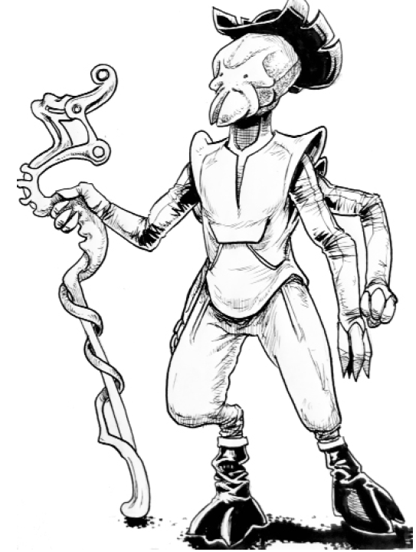

(from X-boat Special Supplement 1: Contact!, p.4)

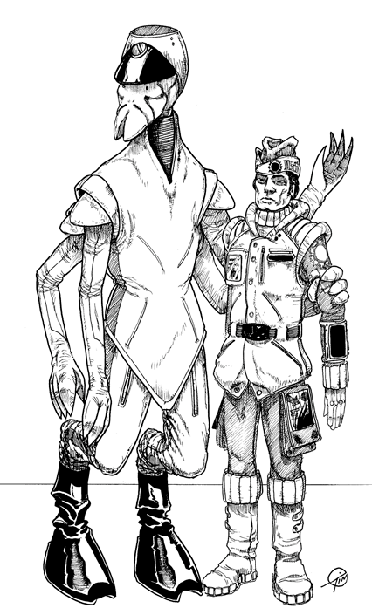

(from Imperiallines 6, p. 4)